**Mud Creek Land Use Scenario Development (Jessica Nelson,** [**jnel@iastate.edu**](mailto:jnel@iastate.edu)**; R. Magala, J. Tyndall):**

In the Mud Creek Watershed (HUC 12; ~36K ac) and surrounding HUC 12 watersheds, we are exploring opportunities for perennial feedstock systems (e.g., vegetation based conservation practices: prairie buffers, cover crops and dedicated energy crops) within a 10-mile radius of Sievers Family Farm (see figure 1).

Spatially, feedstock “opportunities” are defined by estimated **joint-production** potential for biomass systems that also: 1) reduce watershed-scale nitrate-N loss; 2) increase habitat and habitat connectivity at landscape scales (for beneficial insects, pollinators)[1]; 3) sequester carbon; and when possible 4) capture field-level financial benefits associated with alternative crops on chronically unprofitable cropland.

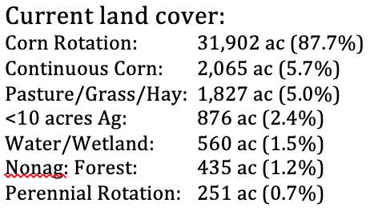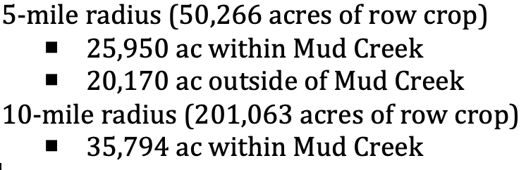

**Figure 1:** Mud Creek Watershed (HUC 070801030303), current land cover, and “supply shed” delineation at 5- and 10-mile radius of Sievers family Farm.

**Initial Analytical Tools:** The Agricultural Conservation Planning Framework (ACPF) identifies opportunities for best management practice (BMP) placement at in-field, edge-of-field, and riparian locations to enhance water quality in agricultural landscapes (<https://acpf4watersheds.org/>). ACPF uses LiDAR, NASS CDL data, gSSURGO soils, field & watershed boundaries, along with hydro-conditioning, terrain processing, and hydro-enforcement of elevation data to ID opportunities for in-field and edge-of-field BMPs at Hydrologic Unit Code 12 (HUC 12) scales (~15 to 40K acres). The Financial & Nutrient Reduction Tool (FiNRT; <https://acpf4watersheds.org/toolbox/finrt/>) is an ACPF- tool that calculates total long-term direct and opportunity costs, expected field & watershed scale nitrate loss and cost effectiveness of various conservation scenarios. The G2G relevant practices are prairie buffers (riparian, contour), grass waterways, and cover crops.

**Our initial scenarios** are designed to begin conversations about land use factors that can/should be modeled to explore multiple economic and environmental outcomes associated with system planning. We’ve created a few conservation-oriented scenarios to serve as starting conditions. Initial conditions for Mud Creek watershed have been modeled and subsequent comparative scenarios integrate different combinations of perennial vegetation/or cover (e.g., prairie strips, buffers, cover crops) in targeted locations that will reduce field nitrate-N loss into Mud Creek. We also have estimated carbon sequestration, total biomass yield, and cost. Table 1 summarizes the results of some of our initial comparative analysis. **Subsequent analysis will examine**: P & sediment reduction, habitat connectivity, biomass harvest logistics (for habitat and irregular cost due to non-uniform feedstock plantings)/ storage logistics, breakeven prices for biomass, sub-field financial outcomes, and total biogas production capacity.

**Table 1.** Watershed management scenarios for Mud Creek Watershed and comparison of the reduction outcomes in relation to nitrate-N in field runoff, carbon sequestration, cost of implementation, and estimated biomass yield. The 3 practices included in this analysis are prairie strips (PS), riparian buffers (RB) and a cereal rye cover crop (CC). Each scenario is compared to Mud Creek’s current conditions (which include riparian buffers, cover crops and prairie strips). Each scenario was estimated based on best management practice (BMP) siting output from the ACPF and economic values using FiNRT. Each scenario is illustrated using outputs from ACPF on the next page.

|  |  |  |  |  |  |  |  |  |  |  |  |  |  |  |  |  |  |  |
| --- | --- | --- | --- | --- | --- | --- | --- | --- | --- | --- | --- | --- | --- | --- | --- | --- | --- | --- |
|  | Existing Conditions a | | | Cover Crop Focus b | | | | | | Prairie Strip Focus c | | | | | | Prairie Strip + Cover Crop d | | |
| 20% | | | 100% | | | 120 ft CBS | | | 30 ft CBS | | |
| PS | RB | CC | PS | RB | CC | PS | RB | CC | PS | RB | CC | PS | RB | CC | PS | RB | CC |
| Acres in Practice | 0.7 | 626 | 731 | - | - | 4,685 | - | - | 23,903 | 3,314 | - | - | 732 | - | - | 516 | - | 1,972 |
| Perennial Cover  (% of watershed) | 3.7 (initial perennial cover) | | | 12.9 | | | 65.7 | | | 9.1 | | | 2.0 | | | 6.8 | | |
| Total Cost per Year | $193,000 | | | $342,000 | | | $1,746,000 | | | $834,000 | | | $186,000 | | | $287,000 | | |
| Nitrate-N Reduction (%) | 13.2% | | | 3.9% | | | 20.2% | | | 29.1% | | | 11.3% | | | 14.0% | | |
| Total Nitrate Reduction | 126,079 | | | 37,654 | | | 192,915 | | | 277,426 | | | 107,547 | | | 133,355 | | |
| Cost Effectiveness ($ / lb N) | $21.91 | | | $9.16 | | | $9.10 | | | $3.57 | | | $1.78 | | | $3.48 | | |
| Carbon & C02eq (total tons) e | 235 | | | 1,499 | | | 7,649 | | | 3,248 | | | 717 | | | 1,137 | | |
| Biomass Yield (tons) f | 827 | | | 5,294 | | | 27,010 | | | 6,297 | | | 1,391 | | | 3,209 | | |

a The Existing Conditions scenario represents the best management practices that we can visually see in aerial imagery, including riparian areas treated with conventional ditch buffers (16.5 ft to 50 ft filter strips established with cool-season grasses), as well as contour buffer strips. It is assumed that 4% (reference) of the fields currently use a cereal rye cover crop. The presence of additional practices is currently unknown and not included in the analysis, including bioreactors, saturated buffers, drainage water management, nutrient removal wetlands, and farm ponds.

b The Cover Crop Focus scenarios include two different changes in crop field management. The first depicts the outcome if 20% of crop fields were planted with a cereal rye cover crop in the winter, while the second scenario describes the outcome if 100% of crop fields were managed with cereal rye cover crop. There are zero acres of land taken out of a corn-rotation.

c The Prairie Strip focus scenarios include two different crop land conversions in fields with greater than 5% mean slope. The first depicts the outcome if 120 ft strips of native prairie vegetation were installed along field contours, while the second describes the outcomes if those prairie filter strips were 30 ft instead.

d The Prairie Strip + Cover Crop scenario includes cereal rye cover crops on 20% of the fields with mean slopes between 3 to 5% and 120 ft prairie strips installed along the contours of crop fields with greater than 10% mean slope.

e Estimated that riparian herbaceous and contour buffer strips reduce 0.98 Mg CO2 & 0.28 Mg C02eq in NO­x per acre losses and cover crops reduce 0.32 Mg CO2 & 0.05 Mg C02eq in NOx per acre; Assumes practice is in place for at least 10 years. Data: Swan et al. 2020.

f The average biomass yields for cover crops is approximately 1.13 tons per acre as per D. Tyndall (Pers. Comm.) & 1.9 tons (unfertilized) to 3.38 tons (fertilized) per acre in prairie systems (COBS field data; Nichols et al. 2014).

**References**: Nichols et al. (2014). Comparison of cellulosic ethanol yields from midwestern maize and reconstructed tallgrass prairie systems managed for bioenergy. *BioEnergy research*, *7*(4), 1550-1560; Swan et al. 2020. COMET-Planner Dataset, Version 2.1, Build 1, and COMET-Planner Report: Carbon and Greenhouse Gas Evaluation for NRCS Conservation Practice Planning.

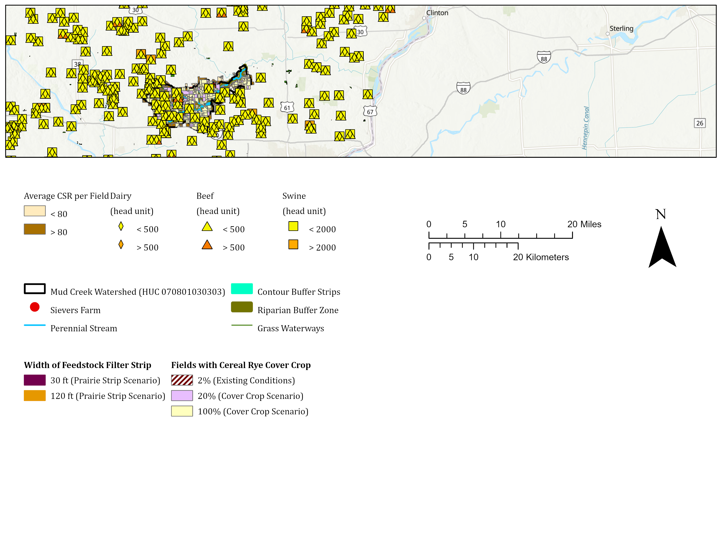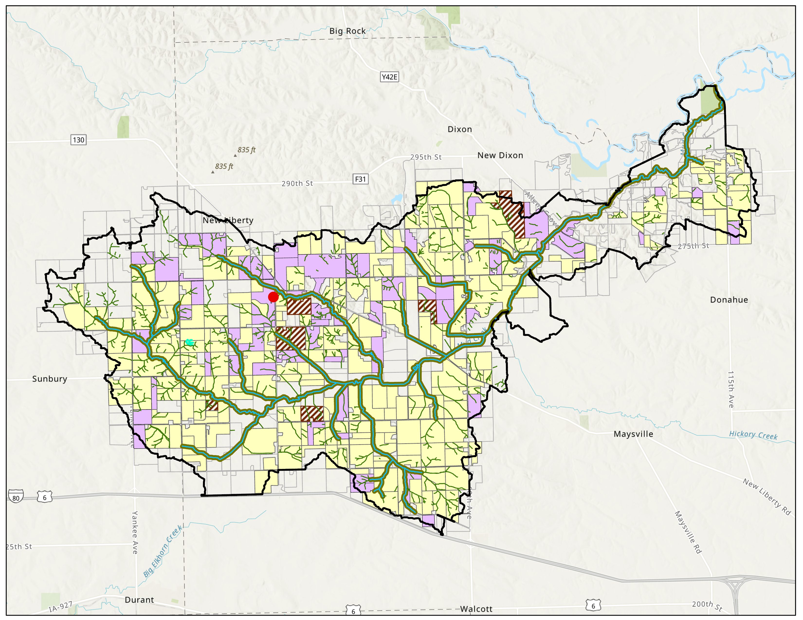

**Existing Perennial Practices**

****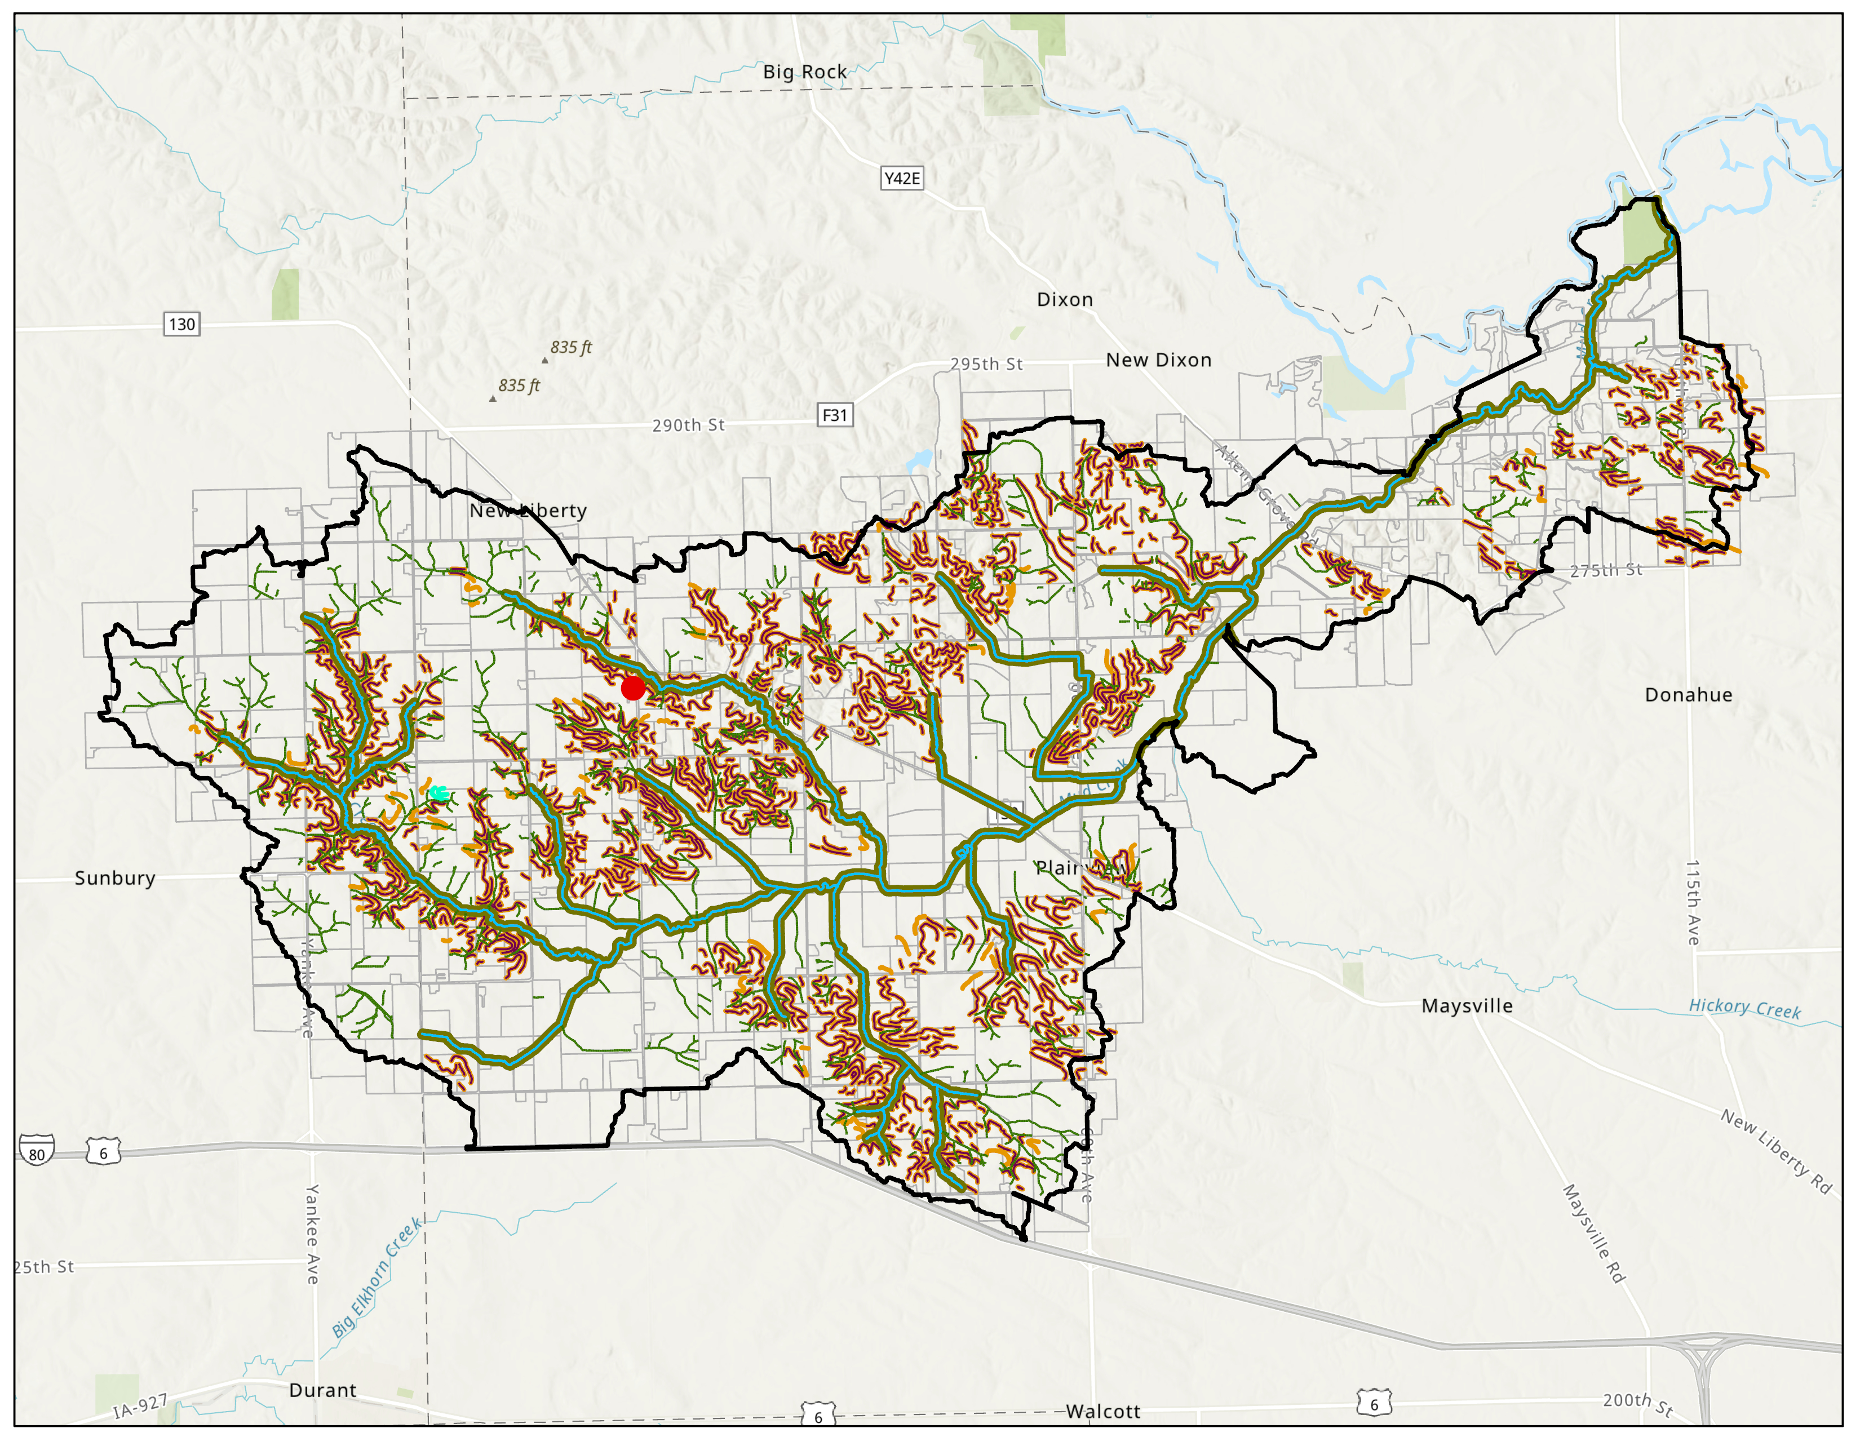

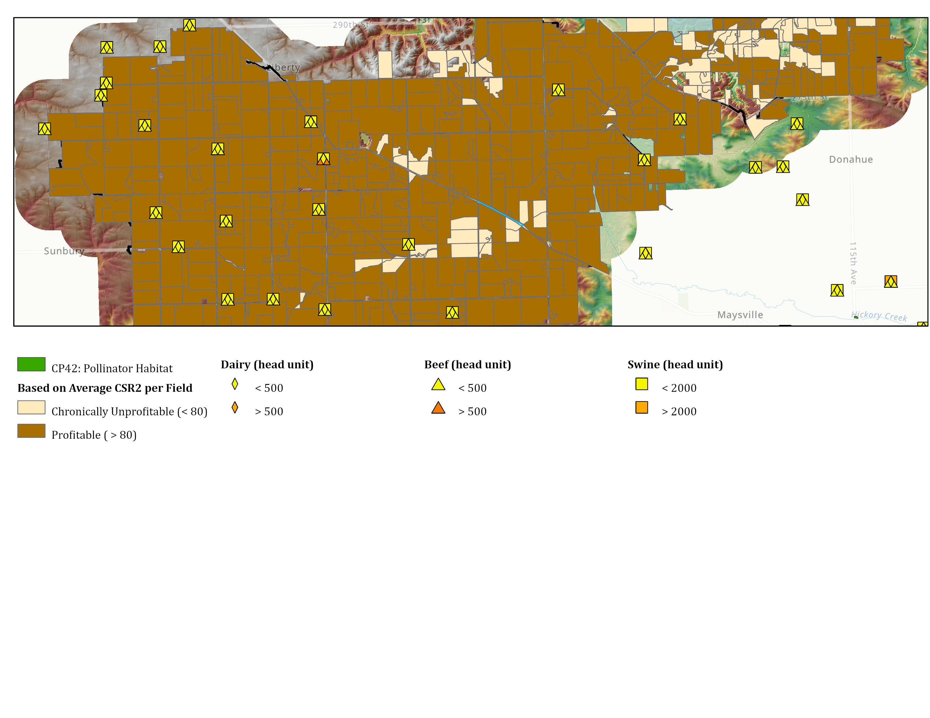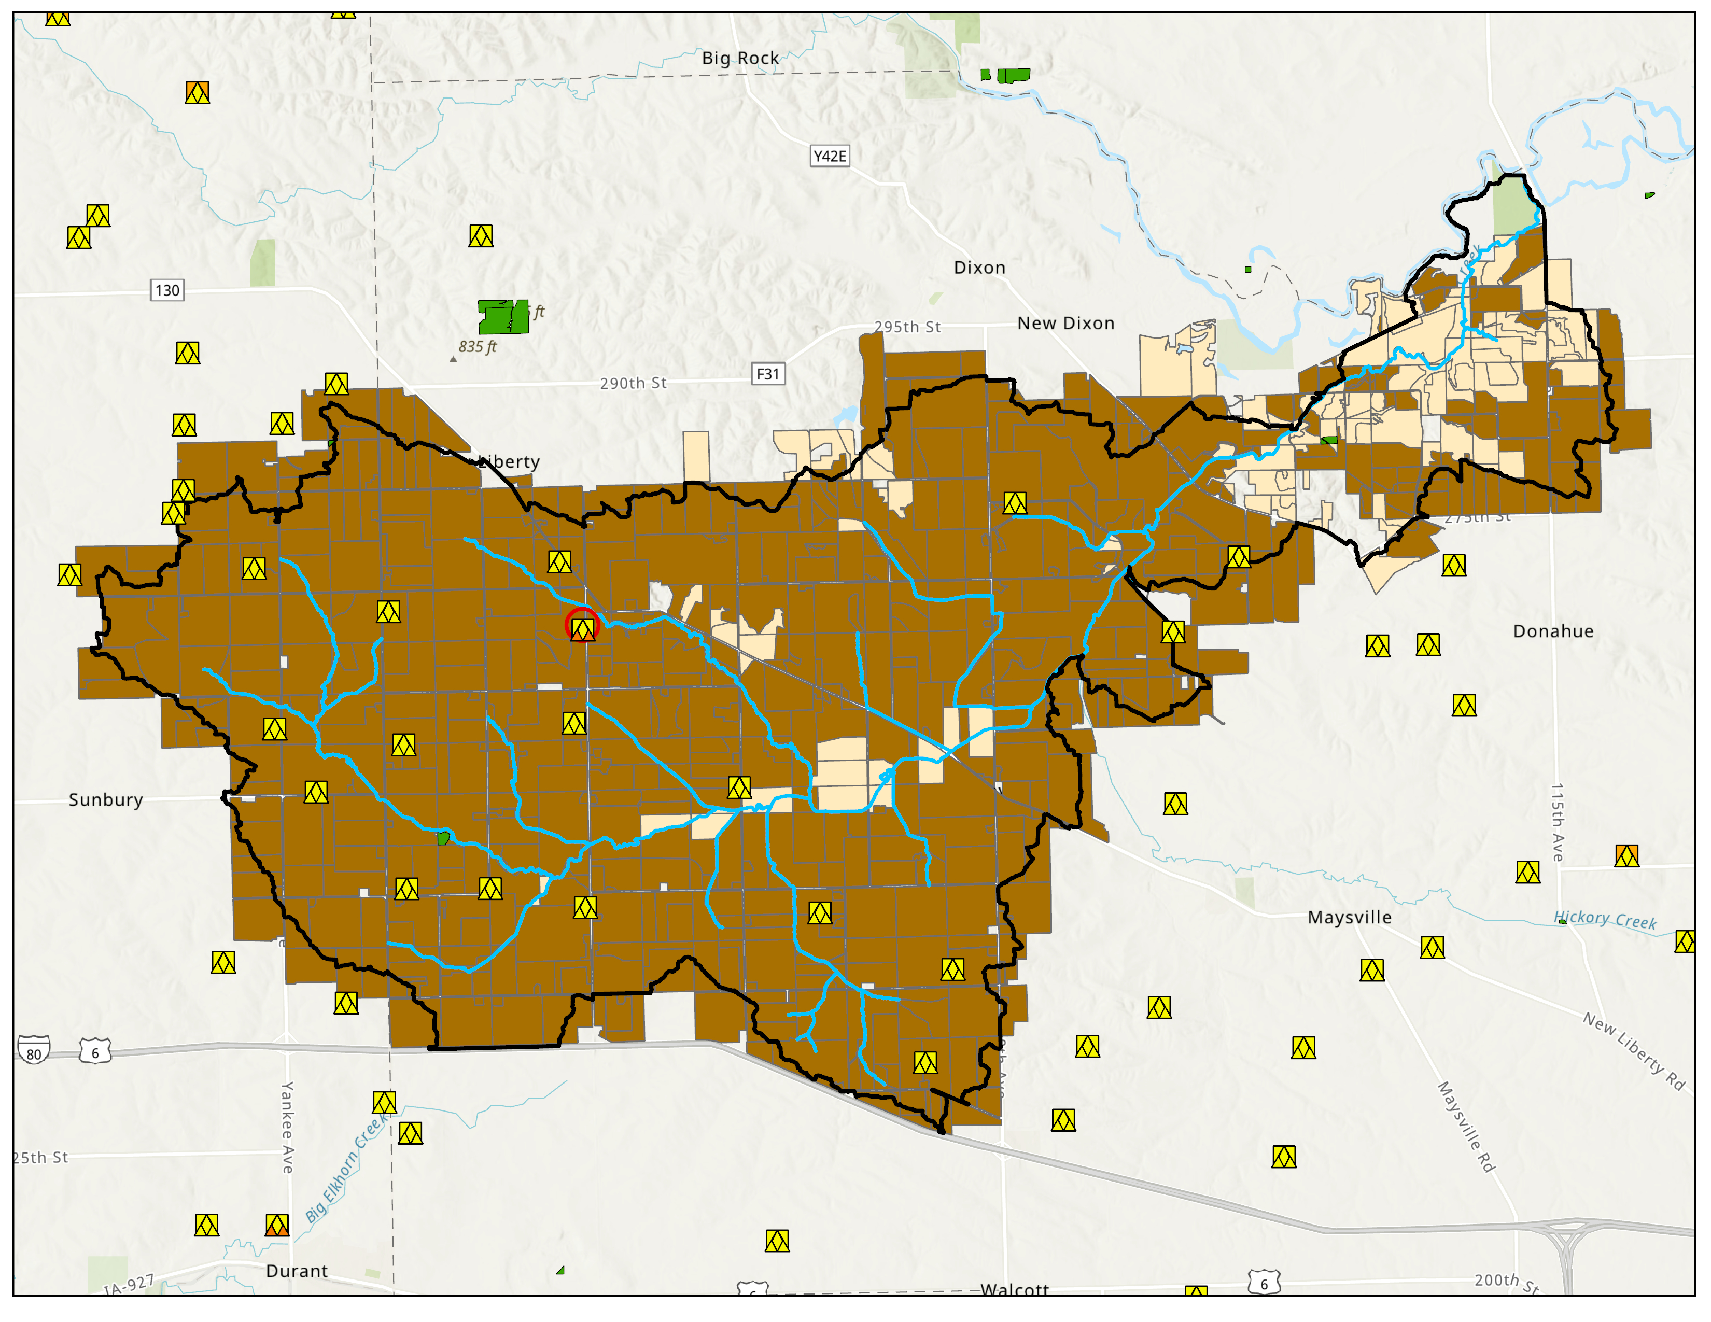

**Elevation (feet)**

834

627

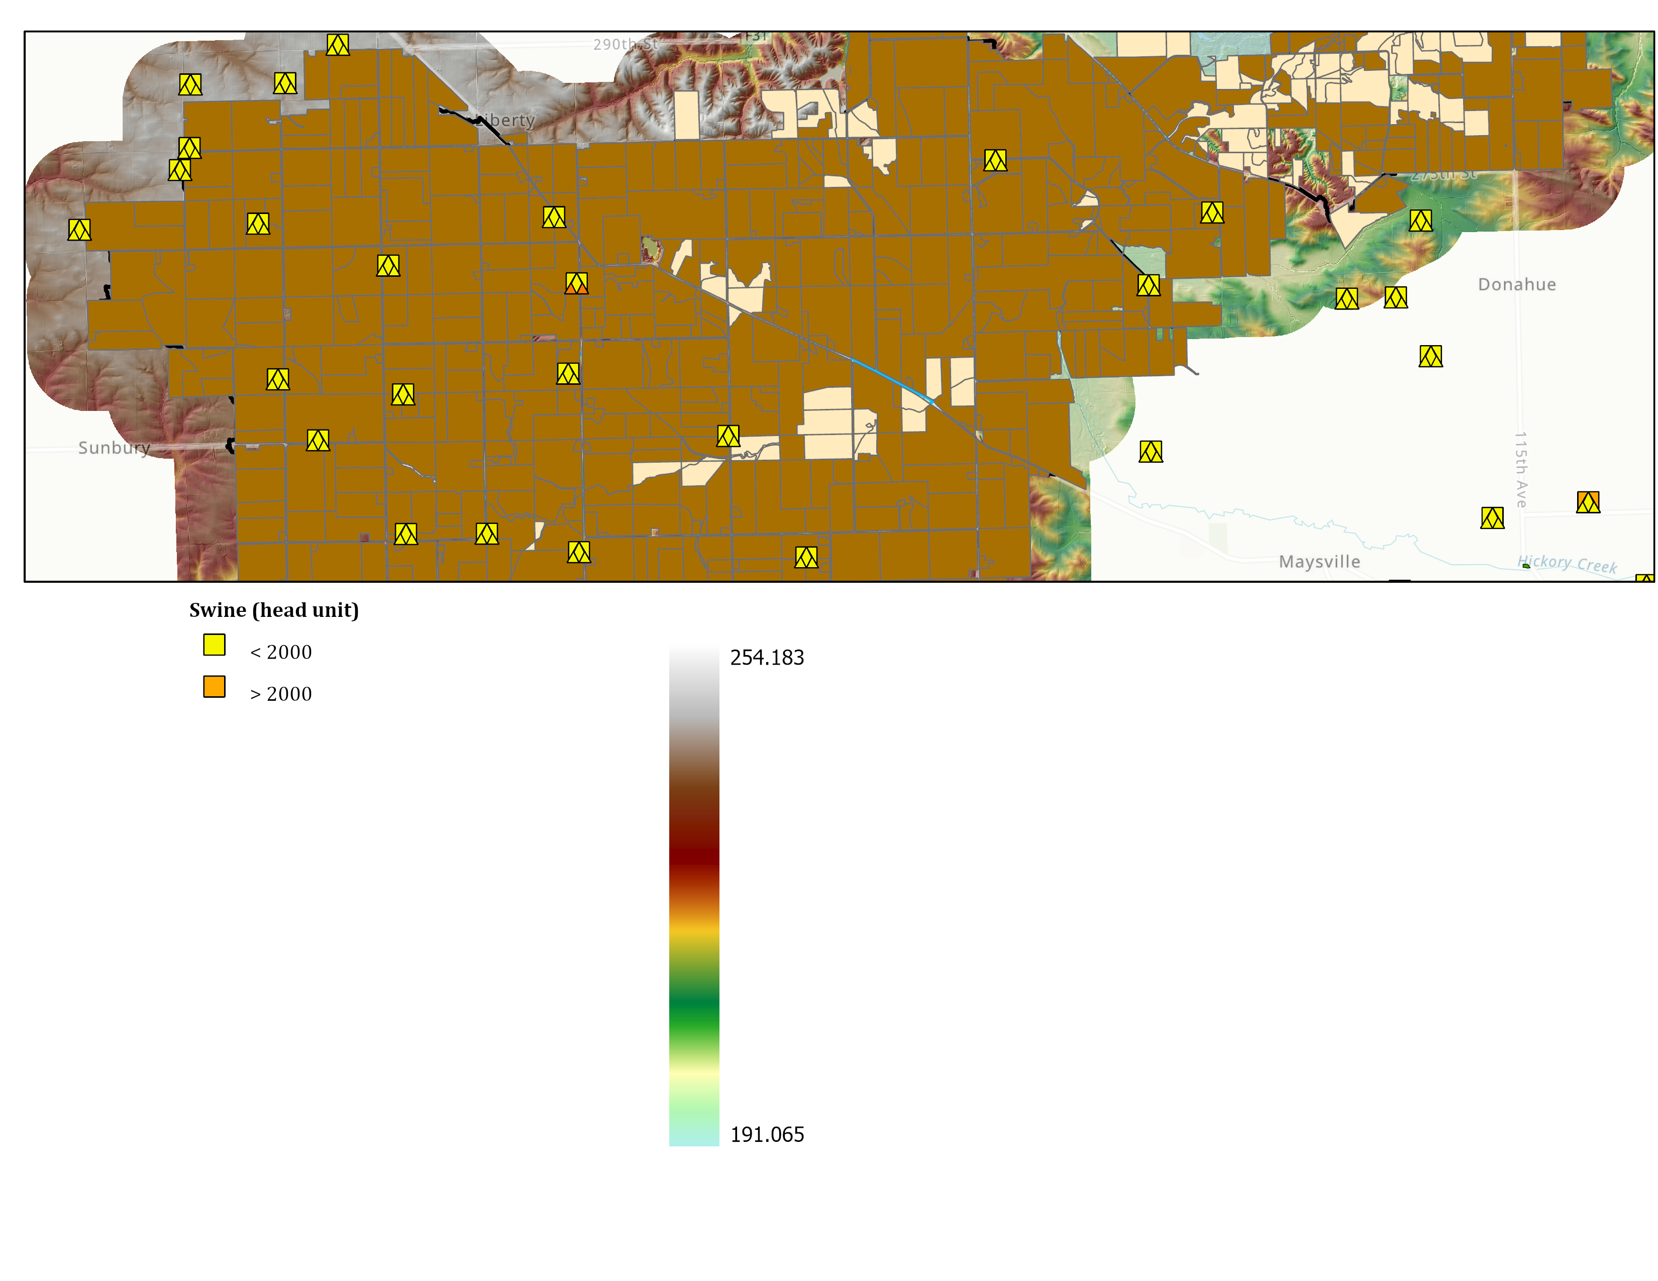

**\***



*CSR2 is based on crop and soils data between 2016-2020.



****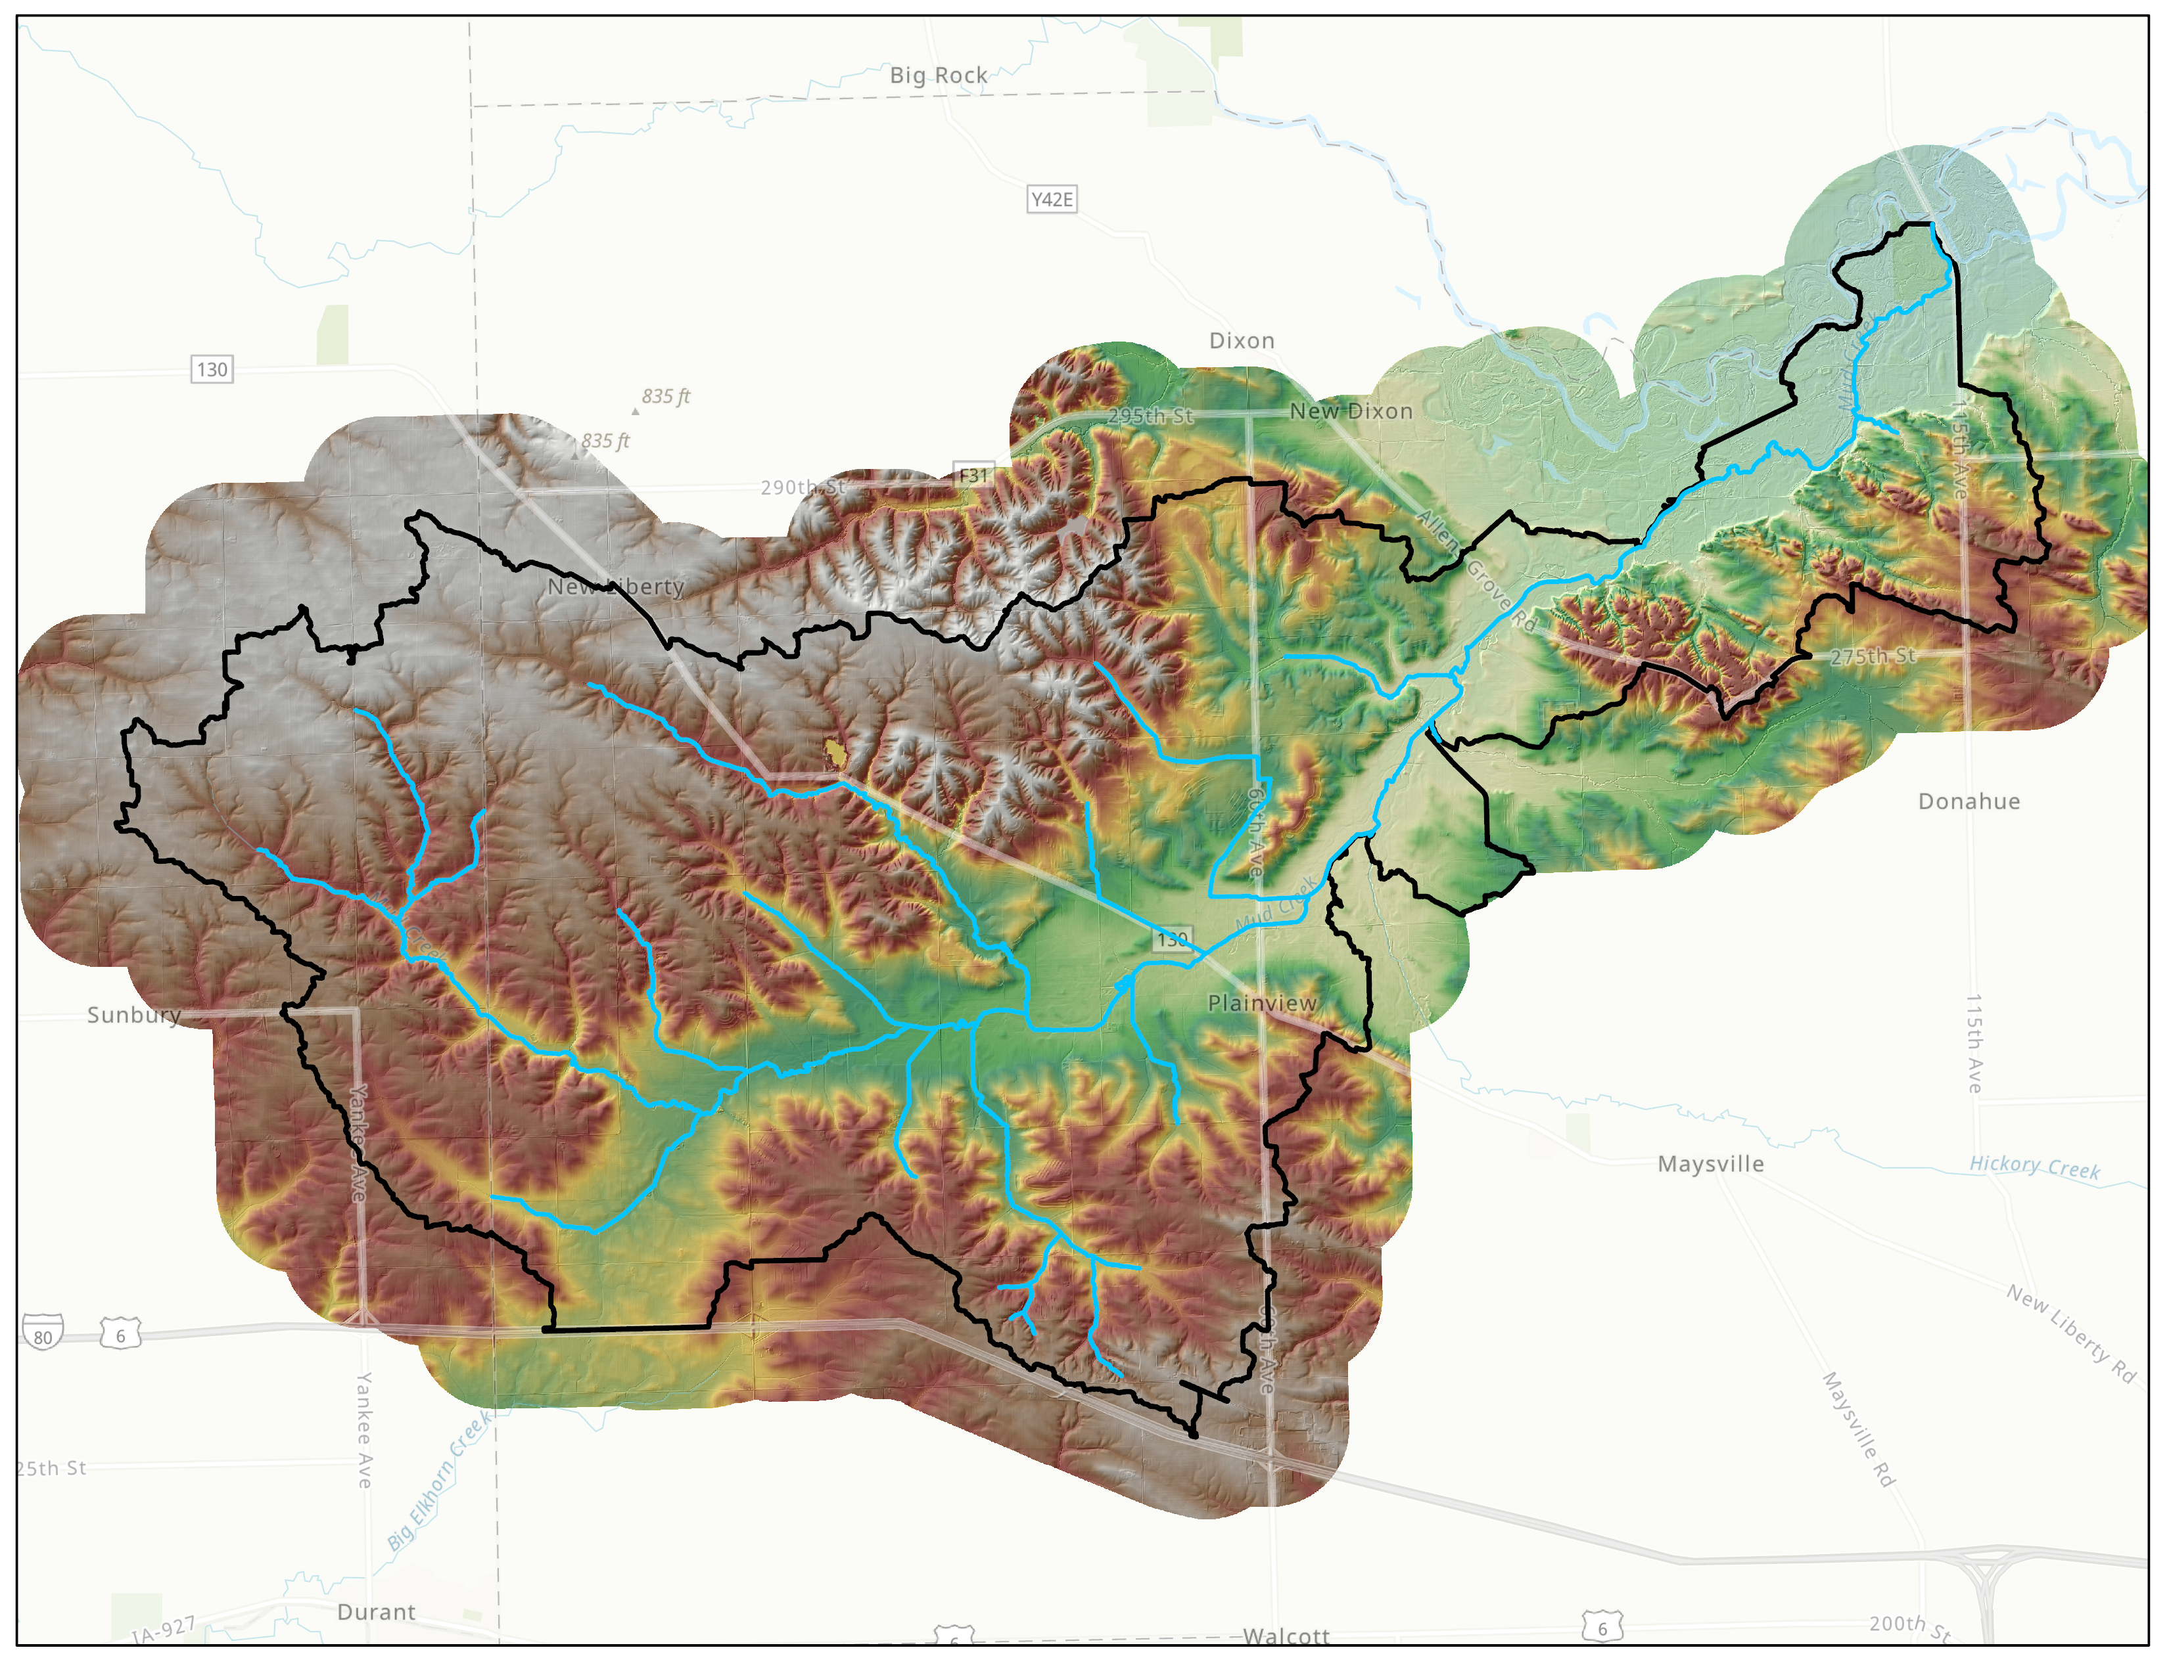

1. Watershed-scale water quality and habitat outcomes associated with perennial conservation have varying degrees of spatially explicit considerations associated with topography, runoff patterns, drainage, landscape positions, and connectivity. At landscape scales, carbon management via conservation practices is more dependent on the overall scale of application, site conditions, and long-term management than upon explicit spatial considerations.